 | Address  [Contact Number] |  | 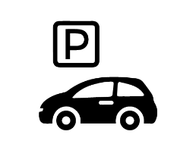
 | PARKING RECEIPT
 | Ticket#: | 0000000
 | Time: | 00:00 PM
 | Date: | 00/00/00
 | Duration: [Hours] [Minutes]
 | PAID: $0
THANK YOU
AND DRIVE SAFELY

